Access to specific branch in aws

1. Need to update the policy in aws iam user.
2. Create a json file in iam user.Goto iam ,-->policies---->click create policy.

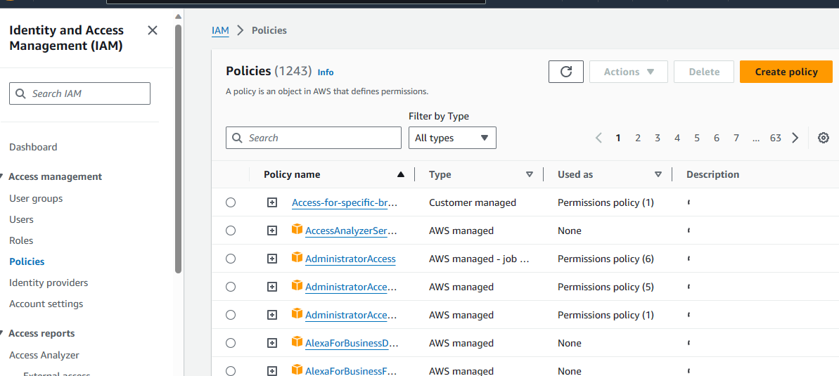

1. Select json and Add this allow json code in that policy.

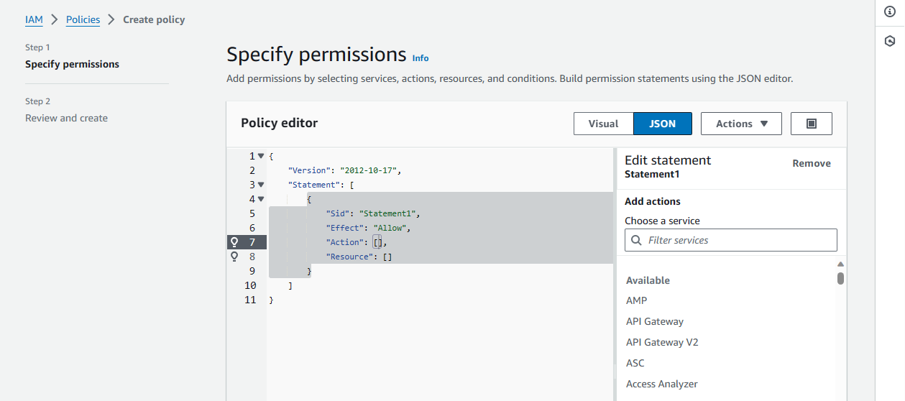

1. {
2. "Version": "2012-10-17",
3. "Statement": [
4. {
5. "Effect": "Allow",
6. "Action": [
7. "codecommit:GitPull",
8. "codecommit:GitPush"
9. ],
10. "Resource": " arn:aws:codecommit:us-east-2:760468531835:iStoryLive "
11. },
12. {
13. "Effect": "Deny",
14. "Action": [
15. "codecommit:GitPull",
16. "codecommit:GitPush"
17. ],
18. "NotResource": [
19. " arn:aws:codecommit:us-east-2:760468531835:iStoryLive "
20. ]
21. }
22. ]
23. }
24. In above code replace the repo ARN "Resource": "arn:aws:codecommit:region:account-id:repository-name"
25. Go to codecommit-->goto repo --> goto repo setting --> copy the repo arn and paste it in json file and save it. 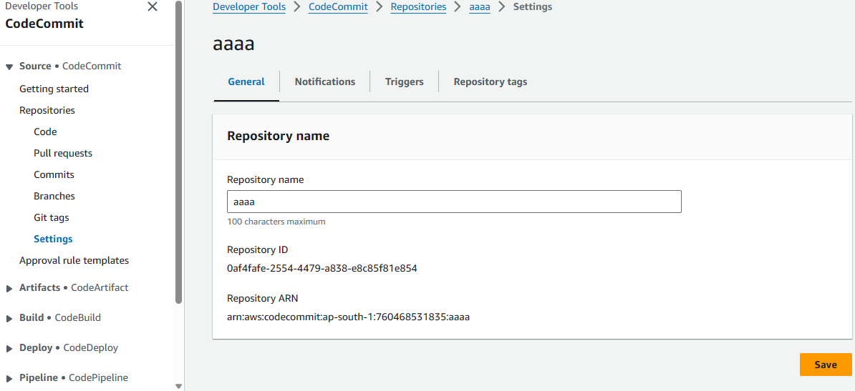
26. Save the json file 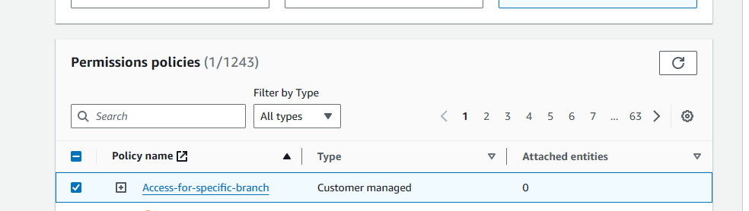
27. Attach this policy to that specific user.
28. 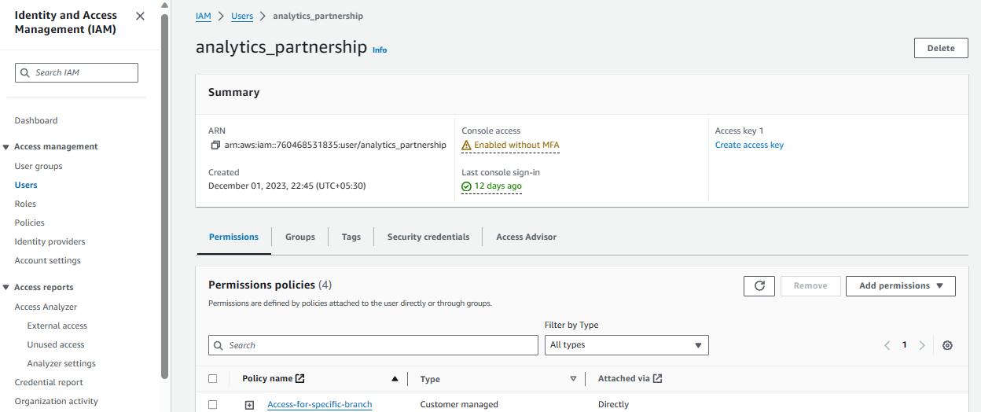
29. If he try to access the some otherrepos it will throw error like below

